**Git Config Commands**

Whatever we made changes in local repository that should be tracked by git with introduction yourself to git with git config commands

***Introduce yourself to git***

Start with below commands

git config –global user.name

git config –global user.email

***To display user details***

git config –global user.name

git config –global user.email

***To display the list***

git config –list

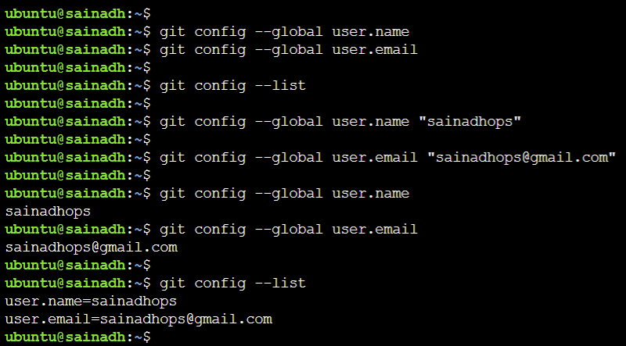

To remove configuration , the command is

git config --global --edit